Group _____________ Name _________ No red!

Writing Task on Expressing an Opinion (2 tasks)

Task 1
Сomplete the outline
Step 1 On the first line, write an opinion topic sentence.
Step 2 Think of two or three reasons for your opinion and write them on the appropriate lines.
Step 3 Think of possible supporting details for each reason, and write them on the appropriate lines.
Step 4 Write a concluding sentence on the appropriate line.
Use the Example
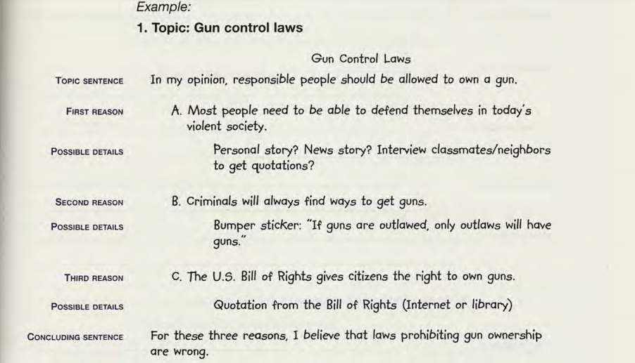
Topic: Using cell phones in public places
Using cell phones in public places

Topic sentence

A.First reason

Possible details

B.Second reason

Possible details

C.Third reason

Possible details

Concluding sentence

Task 2
Write an essay Using cell phones in public places according to your outline.

